- NY REAL ESTATE COMMERCIAL
- May 12, 2013, 10:59 p.m. ET

Playing the Middle

Developer's Strategy Involves Sprucing Up Midsize Buildings to Increase Value

By ANJALI ATHAVALEY
An office building across the street from Rockefeller Center that will soon be home to a New York Yankee-branded steakhouse is about to get a major upgrade.
Turkish investor Demir Sabanci bought the 44,000-square-foot building at 7 W. 51st St. for $29 million in 2010. He's investing $2 million to renovate the lobby, upgrade elevators and install a new fire-alarm system. Construction is expected to begin within a month.

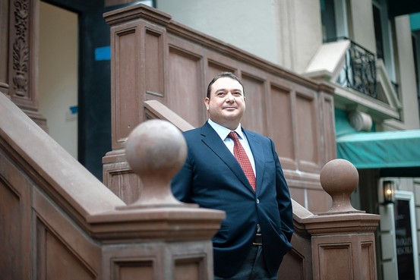
Keith Bedford for The Wall Street Journal
Developer Demir Sabanci of Sedesco Holdings, who owns the 44,000-square-foot building at 7 W. 51st St.
Mr. Sabanci's New York-based company Sedesco Inc. last year signed a lease for the bottom three floors with NYY Steak, a joint venture between the Yankees and Hard Rock International. The restaurant, which has another location at Yankee Stadium in New York, is planning to open later this year.
The renovations of the nine-story building are part of Mr. Sabanci's strategy to buy midsize office buildings in Midtown and the Upper East Side and increase their value—and their rents—by giving them a makeover.
Mr. Sabanci's family owns an industrial conglomerate in Turkey, but around 2005, he decided to go off on his own.
He founded Sedes Holding, which is based in Turkey and has interests in a wide range of industries including electronics and retail. While the bulk of his business is in Turkey, he has spent roughly $100 million on four buildings in the city.
His portfolio in Manhattan includes the Weston House, an office building at East 64th Street and Madison Avenue.
Another is the Banca Di Roma building at East 51st Street between Park and Madison avenues. The building has been demolished, and Mr. Sabanci plans to build a 22-story office tower there.
He believes that midsize buildings in prestigious locations will enjoy strong demand from tenants even during tough times. "Even in a crisis environment…they don't have to sacrifice address and location," he says.
Mr. Sabanci's first purchase in Manhattan was the Weston House, which he bought in 2007 near the market's peak. But his other acquisitions took place after the downturn hit, and as a result, he was able to buy them at bargain prices.
His approach could pay off. He says he already got an offer on his office building at East 61st Street and Madison Avenue for 60% more than he paid. Mr. Sabanci bought the building for $21 million.
He says he wasn't interested in selling, but he points out: "I know at least one of them appreciated,"
At his nine-story building on West 51st Street, the steakhouse will have seating for 264 diners. The rest of the building is fully leased with the exception of one floor.
Other tenants include a dentist, Shizuka New York Day Spa and Banco Popular.
"I thought a high-traffic tenant like the Yankees would benefit the tenants upstairs," Mr. Sabanci says.
Corrections & Amplifications
An earlier version of this article incorrectly said that NYY Steak had one other location at Yankee Stadium. NYY Steak also has a location in Coconut Creek, Fla.
Write to Anjali Athavaley at anjali.athavaley@wsj.com

